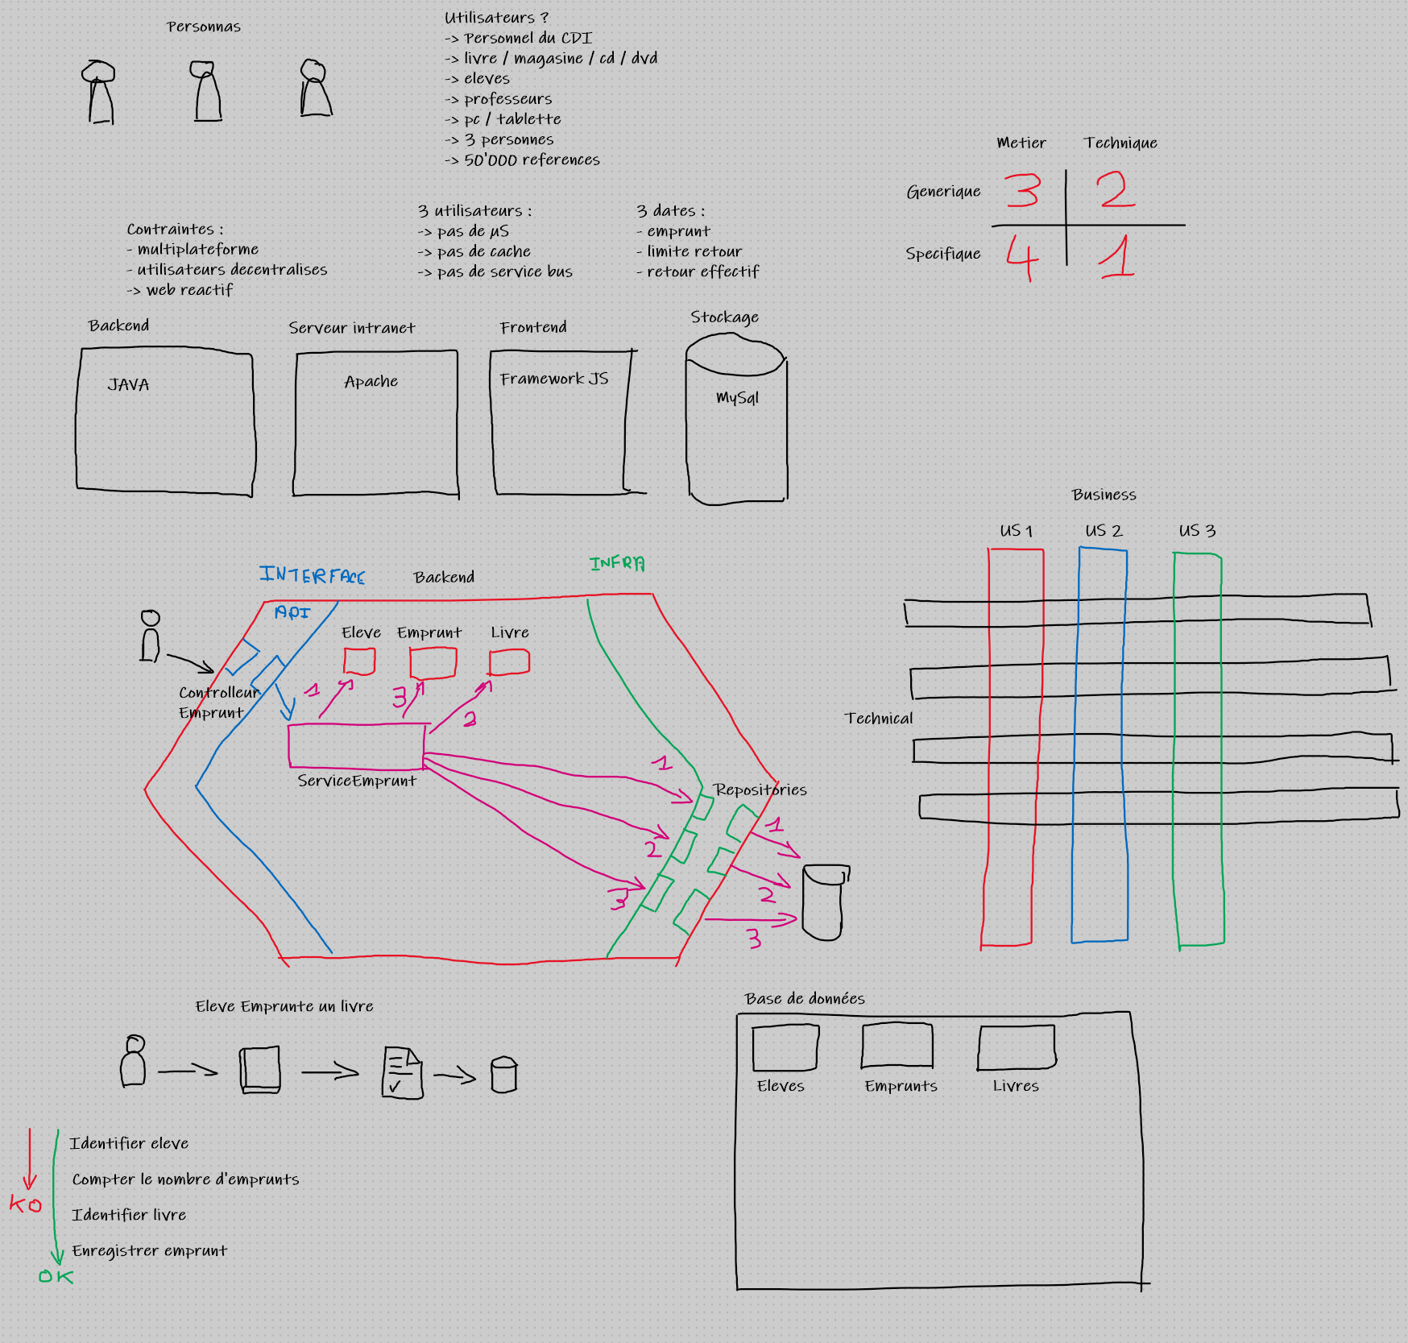
entity + repository = model

Design pattern Mvx :
-MVC
-MVT
-MVVM

